**STUDY COMRADE PVT.LIM**

**NAME: JASMINE JOICY. A**

**DEPARTMENT: B.TECH AI & DS**

**ROLL NUMBER: 17**

**DATE OF SUBMISSION: 08.06.2025**

**ASSIGNMENT 1:**

[**https://683b051051d0806db7d68b2e--playful-cobbler-125051.netlify.app/**](https://683b051051d0806db7d68b2e--playful-cobbler-125051.netlify.app/)

**ASSIGNMENT 2:**

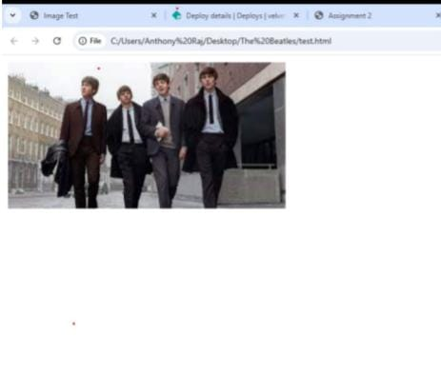

**ASSIGNMENT 3:**

[**https://683b185a78f84c7834780b36--bright-gumdrop-598f46.netlify.app/**](https://683b185a78f84c7834780b36--bright-gumdrop-598f46.netlify.app/)

**ASSIGNMENT 4:**

[**https://683b185a78f84c7834780b36--bright-gumdrop-598f46.netlify.app/**](https://683b185a78f84c7834780b36--bright-gumdrop-598f46.netlify.app/)

**ASSIGNMENT 5:**

[**https://683b1dfd652ef6b0c0940fd0--stalwart-gumdrop-3224a0.netlify.app/**](https://683b1dfd652ef6b0c0940fd0--stalwart-gumdrop-3224a0.netlify.app/)

**ASSIGNMENT 6:**

[**https://683b20987d53c796f5471ee6--vocal-travesseiro-95caac.netlify.app/**](https://683b20987d53c796f5471ee6--vocal-travesseiro-95caac.netlify.app/)

**ASSSIGNMENT 7:**

[**https://68458c799f76a80ab34e7469--bright-chaja-a5f2fc.netlify.app/**](https://68458c799f76a80ab34e7469--bright-chaja-a5f2fc.netlify.app/)

**ASSIGNMENT 8:**

[**https://684592e9774a718015b2fea8--tourmaline-kashata-6f5658.netlify.app/**](https://684592e9774a718015b2fea8--tourmaline-kashata-6f5658.netlify.app/)

**ASSIGNMENT 9:**

[**https://684597f39928c859708382c6--calm-tanuki-880a1f.netlify.app/**](https://684597f39928c859708382c6--calm-tanuki-880a1f.netlify.app/)

**ASSIGNMENT 10:**

[**https://68459a94700eac3bcead5394--sensational-eclair-77f2c0.netlify.app/**](https://68459a94700eac3bcead5394--sensational-eclair-77f2c0.netlify.app/)

**MINI PROJECT:**

**https://68459bb71753827dca28871e--dazzling-eclair-4fdaea.netlify.app/**